1xx - Controls | 2xx - Ground | 3xx - Flight | 4xx - A2A | 5xx - A2G | 6xx - Misc
509c - A/G - Pilot - AGM-45 Shrike seekers

all information below is WIP and unverified unless marked "tested"

tested seekers
Seeker | Target | Tracks | Tone/Steering
Mk 49 mod 1 | SAM SA-2 S-75 "Fan Song" TR | Yes, only when TR is actually guiding a missile? or locked? | No
 | SAM SA-2/3/5 P19 "Flat Face" SR | No | No
 | SAM SA-3 S-125 "Low Blow" TR | Yes | Yes
Mk 50 | SAM SA-2 S-75 "Fan Song" TR | Yes | Yes
 | SAM SA-2/3/5 P19 "Flat Face" SR | No | No

Emitter
SAM SA-2 S-75 "Fan Song" TR | Mk 49 mod 1: tracks, no tone  Mk 50: tracks, tone

Reference info
Short cheat sheet, prioritizing seekers that will provide tone against chosen emitter:
SA-2 S-75 - Mk 22
SA-3 S-125 - Mk 36, Mk 49
SA-5 S-200 - Mk 23, 24, 50 - search only
SA-10 S-300 - Mk 23, Mk 50 (Mk 36, 49 for Clam Shell, no tone)
SA-6 Kub - Mk 36, Mk 49
SA-11 Buk - Mk 49
SA-8 Osa - Mk 49 (and SA-3, SA-6)
SA-19 Tunguska Mk 23
--https://www.blindflying.com/2024/09/dcs-f-4e-agm-45-shrike.html, 2024-09-28

From https://forum.dcs.world/topic/349673-agm-45-shrike-quick-guide-by-klarsnow-updated-june-5th-2024/, not sure if correct or complete:

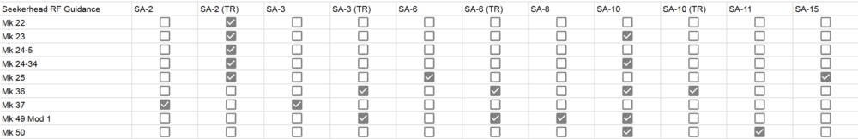
List of all radars in the game:
Unit name | F-4E RWR symbol | Seeker
SAM SA-2/3/5 P19 "Flat Face" SR
SAM SA-2 S-75 "Fan Song" TR
SAM SA-2 S-75 RD-75 Amazonka RF
SAM SA-3 S-125 "Low Blow" TR
SAM SA-5 S-200 "Square Pair" TR
SAM SA-5 S-200 ST-68U "Tin Shield" SR
SAM SA-6 Kub "Straight Flush" STR | 6??
SAM SA-8 Osa "Gecko" TEL | 8??
SAM SA-10 S-300 "Grumble" Big Bird SR
SAM SA-10 S-300 "Grumble" Clam Shell SR
SAM SA-10 S-300 "Grumble" Tin Shield SR
SAM SA-10 S-300 "Grumble" Flap Lid-A TR
SAM SA-10 S-300 "Grumble" Flap Lid-B TR
SAM SA-11 Buk "Gadfly" Fire Dome TEL
SAM SA-11 Buk "Gadfly" Snow Drift SR
SAM SA-13 Strela 10M3 "Gopher" TEL
SAM SA-15 Tor "Gauntlet"
SAM SA-19 Tunguska "Grison"
AAA Fire Can SON-9
SPAAA ZSU-23-4 Shilka "Gun Dish"
MCC-SR Sborka "Dog Ear" SR
EWR 1L13
EWR 55G6

From discord, not sure if correct:

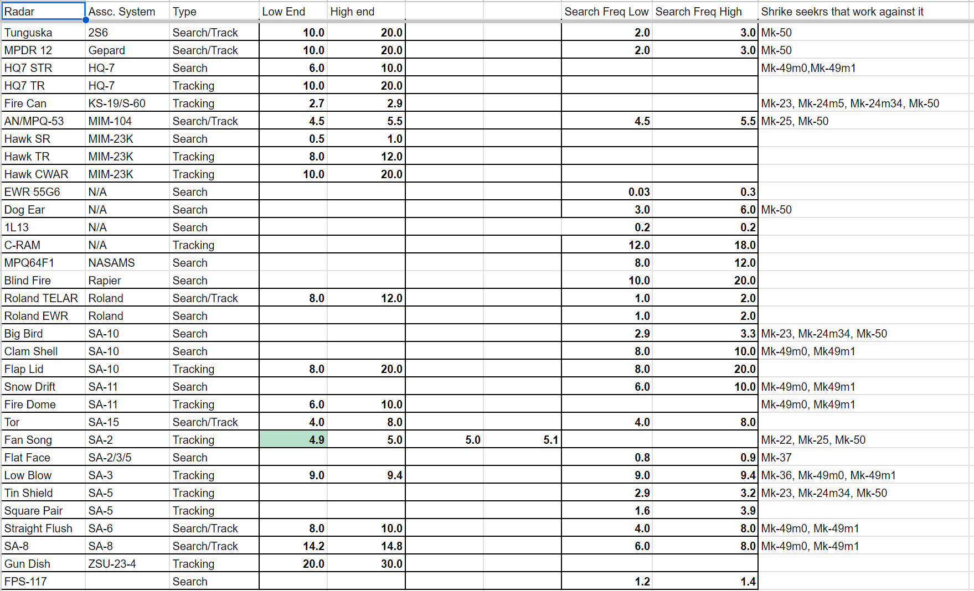
If correct, use the following:
Mk 49 Mod 0/1 | Mk 50
HQ-7 STR | 2S6
Clam Shell (SA-10) | Gepard
Snow Drift (SA-11) | Fire Can (S60)
Fire Dome (SA-11) | Patriot
Low Blow (SA-3) | Dog Ear
Straight Flush (SA-6) | Big Bird (SA-10)
SA-8 | Fan Song (SA-2)
 | Tin Shield (SA-5)

2S6, GepardFire Can (S60),

